Marine Recreational Fishing Effort Summary 2025: St. Lucie County
Prepared for St. Lucie County by Edward Camp (edvcamp@ufl.edu) and Anna Brasawell (a.braswell@ufl.edu), Assistant Professors at the University of Florida, and Vincent Encomio, Florida Sea Grant Extension Agent Martin and St. Lucie Counties vencomio@ufl.edu

How to use this summary
This documents summarizes a full report on the estimated marine recreational fishing effort (number of fishing trips) in St. Lucie County. This information shows the importance of fishing to St. Lucie County economies, stakeholders, and ecosystems, and can inform advertising for fishing-based tourism and local planning in St. Lucie County. The summary augments the full report, which is available from the authors if you do not yet have it.

What information is included and how was it generated
All of the information here comes from the National Marine Fisheries Service (NMFS) Marine Recreational Information Program (MRIP). This summary describes fishing effort annually (trends over time, 1995-2024) and seasonally (average trips per month from 2020-2024). For annual trends, the information is described by fishing mode–the type of fishing trip. There are three modes provided in MRIP: shore-based, for-hire (guided trips, charters, party boats, etc.), and private or rental vessel. The seasonal trends are shown for all modes combined, but greater detail is available in the full report. Data are shown through 2024.

Seasonal pattens in fishing effort
The seasonal patterns of all trips (regardless of mode) is shown in Figure 1. These proportions are the average of the years 2020-2024.
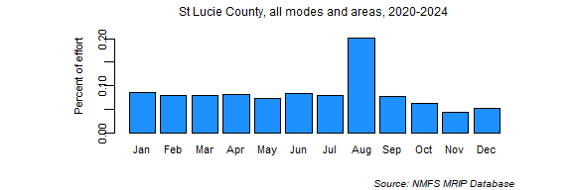
Figure 1. St. Lucie County seasonal patterns of fishing effort, all modes. The percent of total effort from years 2020-2024 occurring in each month.

Annual effort trends by mode
Effort by mode may be important for deciding about things like advertising or allocating funds for shore-based fishing improvement or boat ramps. The trends by mode are shown in Figure 2. The dark blue line is the most likely estimate and the light blue area represents the uncertainty.
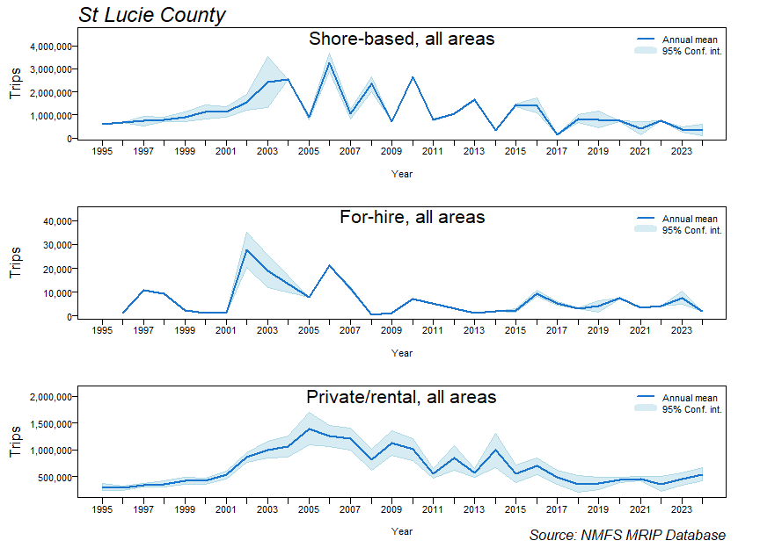
Figure 2. Trends in St. Lucie County fishing effort by mode, for all seasons. The dark blue line is the most likely number of trips and the light blue area shows the uncertainty. Absence of uncertainty can indicate sparse data.

Summary
This summary shows that how marine recreational fishing in St. Lucie County differs by mode over time and varies by season. This information should help inform the way fishing and especially certain modes of fishing are viewed, and it may also inform local governance decisions that affect marine recreational fishing.

